|  |
| --- |
|  |
| Schroder ISF* Asian Total Return  Fund Update  February 2025 |

**Fund Performance**

**Performance of Schroder ISF Asian Total Return (‘C’ Class Accumulation Units)**

Since inception on 16 November 2007, indexed returns in USD

**Calendar year returns (%)**

|  |  |  |  |  |  |  |  |  |  |  |  |  |  |  |  |  |  |  |  |  |  |  |  |  |  |  |  |  |  |  |  |  |  |  |  |  |  |  |  |  |  |  |  |  |  |  |  |  |  |
| --- | --- | --- | --- | --- | --- | --- | --- | --- | --- | --- | --- | --- | --- | --- | --- | --- | --- | --- | --- | --- | --- | --- | --- | --- | --- | --- | --- | --- | --- | --- | --- | --- | --- | --- | --- | --- | --- | --- | --- | --- | --- | --- | --- | --- | --- | --- | --- | --- | --- |
| |  |  |  |  | | --- | --- | --- | --- | |  | Fund | Index | Comparator | | 2024 | 10.9 | 10.2 | 5.3 | | 2023 | 13.9 | 7.4 | 5.0 | | 2022 | -22.9 | -17.5 | 1.5 | | 2021 | 4.7 | -2.9 | 0.1 | | 2020 | 31.0 | 22.4 | 0.7 | | |  |  |  |  | | --- | --- | --- | --- | |  | Fund | Index | Comparator | | 2019 | 18.5 | 19.2 | 2.4 | | 2018 | -14.6 | -13.9 | 2.4 | | 2017 | 40.2 | 37.0 | 1.3 | | 2016 | 7.2 | 6.8 | 0.8 | | 2015 | -2.5 | -9.4 | 0.3 | |

Index: MSCI AC Asia Pacific ex Japan, USD terms.

Comparator: USD 3 Month T-Bill (or an alternative reference rate).

Source: Schroders, bid to bid, with net income invested.

Past performance is not a reliable indicator of future results, the prices of shares and the income from them may fall as well as rise, and investors may not get back the full amount originally invested.

|  |  |  |  |  |  |  |  |  |
| --- | --- | --- | --- | --- | --- | --- | --- | --- |
| % | Feb 2025 | YTD | 1 Year | 3 Years (p.a.) | 5 Years (p.a) | Since Inception  (p.a.) | Standard Deviation  (p.a.) | Sharpe Ratio (RFR = USD 3M T-Bill) |
| **Schroder ISF Asian Total Return (C Class USD)** | -2.7 | -1.4 | 8.5 | 1.2 | 7.3 | 8.5 | 16.6 | 0.4 |
| **MSCI AC Asia Pacific ex Japan index** | 0.2 | 1.6 | 12.5 | 1.5 | 5.0 | 3.2 | 20.1 | 0.1 |
| **USD 3-month T-Bill** | 0.3 | 0.7 | 5.1 | 4.1 | 2.5 | 1.2 | 0.5 | -- |
| **Lipper Equity Asia Pacific ex Japan universe** | 0.9 | 1.2 | 9.5 | -1.6 | 3.2 | 2.3 | 20.0 | 0.1 |
| **Quartile Ranking** | Q4 | Q4 | Q3 | Q2 | Q1 | Q1 | Q1 | Q1 |
| **(Fund Ranking)** | (471/495) | (430/493) | (349/487) | (144/460) | (55/409) | (1/192) | (6/192) | (1/192) |

Lipper universe annualised standard deviations and Sharpe ratios are calculated for the period since the fund’s inception, and annualised returns are calculated based on number of days since inception. For illustrative purposes only and should not be construed as a forecast, prediction, or projection of the future or likely performance of the fund. The fund is not managed with reference to any specific benchmark(s), but its performance may be measured against one or more.

Source: Bloomberg, Lipper IM, Schroders, as at end of February 2025. Quartile data source: Lipper universe.

**FEBRUARY PERFORMANCE**

February proved to be a challenging month for several Asian stock markets and the SISF Asian Total Return Fund. Worries over Trump policies, particularly on trade, along with signs of a slowdown in the technology sector in the USA especially in AI related capital expenditures caused weakness in many stock markets in the region. The Taiwanese and Australian indexes both fell around 5%, whilst messy local politics and disappointing earnings led to sharp falls in Thailand (down 9%) and Indonesia (down 16%). India also continued to correct falling 8% as quarterly earnings again fell short of lofty expectations.

The only stock market that really bucked the trend was the MSCI China index, which is heavily weighted in Chinese internet and technology stocks, which rose 12% over the month. This was all on the back on DeepSeek fervour which led to a huge rally in a relatively narrow range of stocks in the internet, electric vehicles (EV), industrial and semiconductor sectors. We go on to discuss our investment views on the implications of DeepSeek in the outlook section. However, it would be fair to say with retail fervour high, in a market that is always prone to wild swings in sentiment, some of the current stock moves look speculative being based on hope and hubris rather than fundamentals.

Performance was difficult over the month. With the fund’s positioning balanced across Asian stock markets the fund fell 2.7% over the month (C Class shares in US$), this compares with the reference benchmark (MSCI AC Asia Pacific ex Japan index) which rose 0.2%. Even though we have been adding to positions in HK/China over the last six months we remain relatively underweight the market (c.8%) so this was painful. Stock selection was also difficult. Whilst the fund’s second largest holding (Tencent) did well we don’t have exposure to some of the more speculative names in the industrial sector which were bid up on robotic themes and ADAS (self-driving cars) hype. The biggest contributor to underperformance however came from our zero-weight position in Alibaba which rose 35% in February. As we explain later having done a full review, we continue to remain cautious on the stock, and the e-commerce sector in China generally, and prefer names like Tencent, Netease, Meituan and Trip.com (all held in the fund) in the Chinese internet space.

The other smaller negative contributor to performance was our long-held position in Bank Mandiri in Indonesia which fell sharply (25%) in February on worries over the threat of creeping national service obligations and political interference by the new Indonesian Government. We have reviewed the position and decided to stick with it. Political transitions in Indonesia are often messy and noisy and it is early days – we are not comfortable with the direction of travel but feel the stock is discounting a poor scenario.

Elsewhere we had positive contributions to performance from India where our underweight position in the market, relatively defensive stocks and Indian puts all contribution positively to performance. Our position in the Taiwanese technology sector was not a material negative contributor to relative performance. As highlighted in previous monthlies we have been taking profits in our Taiwan technology stocks and whilst we are still overweight this sector it is relatively small, and we don’t hold the racier mid-cap heavily AI focussed/themed stocks. Overall, the fund is neutral in the technology sector.

Summing up a painful month both in absolute and relative terms: looking at the attribution effectively all the material underperformance (vs the reference benchmark) for February came from our underweight position in China and our lack of exposure to a select range of stocks deemed as DeepSeek beneficiaries.

We made a few changes over the month. We added to existing positions in Meituan and Trip.com – using weakness in Meituan over worries over social security obligations as a chance to add, and in case of Trip.com we used the sell off post results (where company announced plans to invest more in its overseas platforms) as an opportunity to materially increase our holding. We also added to one of our Indian positions and started a new position in a fintech related stock in India that has pulled back 40% from its 2024 highs. Purchases were funded by the sale of one of our Taiwan technology stocks, trimming exposure to Singapore banks which have done well, and the partial sale of SK Hynix.

What are our hedging models telling us? Clearly quantitative models cannot pick up Trump tweets and policy vacillations, which perhaps is no bad thing. At the current point our short-term tactical models remain neutral however with a positive bias – suggesting no need for hedging unless put pricing is cheap. Put pricing, with VIX over 20 (at time of writing), is very much not cheap. Our longer-term models (based around mean reversion to standard valuations adjusted for our business cycle indicators) are positive on the smaller ASEAN markets and Korea, but remain noteworthily cautious on China (valuations NOT cheap and cycle indicators poor) and relatively cautious on Taiwan (however this is problematic as TSMC is 50% of index so the decision is really whether we think TSMC deserves to trade at a higher multiple vs history, which we do given it’s much better market positioning after the failure of all its major competitors in advanced nodes). The biggest change to the models however was the move of India from “sell” to neutral after the market correction over the last three months. Given this we have closed out the position in Indian puts which, as highlighted earlier, has been a profitable position. At the current time the fund has no hedging in place, however if put pricing becomes more attractive we would be looking to buy puts on the China and Taiwan indices in-line with the models.

**RISK CONSIDERATIONS**

* Capital risk / distribution policy: As the fund intends to pay dividends regardless of its performance, a dividend may represent a return of part of the amount you invested.
* Counterparty risk: The fund may have contractual agreements with counterparties. If a counterparty is unable to fulfil their obligations, the sum that they owe to the fund may be lost in part or in whole.
* Currency risk / hedged share class: The hedging of the share class may not be fully effective and residual currency exposure may remain. The cost associated with hedging may impact performance and potential gains may be more limited than for unhedged share classes.
* Derivatives risk: Derivatives may be used to manage the portfolio efficiently. The fund may also materially invest in derivatives including using short selling and leverage techniques with the aim of making a return. A derivative may not perform as expected, may create losses greater than the cost of the derivative and may result in losses to the fund.
* Emerging markets & frontier risk: Emerging markets, and especially frontier markets, generally carry greater political, legal, counterparty, operational and liquidity risk than developed markets.
* Higher volatility risk: The price of this fund may be volatile as it may take higher risks in search of higher rewards.
* IBOR risk: The transition of the financial markets away from the use of interbank offered rates (IBORs) to alternative reference rates may impact the valuation of certain holdings and disrupt liquidity in certain instruments. This may impact the investment performance of the fund.
* Liquidity risk: In difficult market conditions, the fund may not be able to sell a security for full value or at all. This could affect performance and could cause the fund to defer or suspend redemptions of its shares.
* Market risk: The value of investments can go up and down and an investor may not get back the amount initially invested.
* Onshore renminbi currency risk: The fund can be exposed to different currencies. Changes in foreign exchange rates could create losses. Currency control decisions made by the Chinese government could affect the value of the fund's investments and could cause the fund to defer or suspend redemptions of its shares.
* Operational risk: Operational processes, including those related to the safekeeping of assets, may fail. This may result in losses to the fund.
* Performance risk: Investment objectives express an intended result but there is no guarantee that such a result will be achieved. Depending on market conditions and the macro-economic environment, investment objectives may become more difficult to achieve.
* Stock connect risk: The fund may be investing in China "A" shares via the Shanghai-Hong Kong Stock Connect and Shenzhen-Hong Kong Stock Connect which may involve clearing and settlement, regulatory, operational and counterparty risks.
* Sustainability risk: The fund has environmental and/or social characteristics. This means it may have limited exposure to some companies, industries or sectors and may forego certain investment opportunities, or dispose of certain holdings, that do not align with its sustainability criteria chosen by the investment manager. The fund may invest in companies that do not reflect the beliefs and values of any particular investor.

**OUTLOOK – A.I. and DeepSeek, updating our views**

We won’t spend time rehashing our views on the overall Asian stock market outlook as hopefully we covered this in the rather long Year of the Snake report last month. As mentioned in the Year of the Snake report we started 2025 relatively cautious on the AI related names in Asia feeling capital expenditure might be vulnerable as AI use cases and monetisation needed to catch up with the huge spend in the sector. In the case of US, Taiwan and Korean technology stocks this currently looks to have been correct.

However, one significant event has occurred since our report was written, that being the release of DeepSeek by a previously little-known Chinese start-up. We assume all readers are familiar with DeepSeek so won’t go into the details, but it does have potentially significant implications. It has also, as highlighted in the Review section, triggered a large rally and speculative fervour in the Chinese technology, industrial and internet sector.

Given it is early days (five weeks since DeepSeek’s release) we are still working through our investment thoughts. However logically to us if DeepSeek (or the coding and processes behind it) can produce an AI platform (or agent) at a fraction of the cost of rivals such as Open AI then it democratises AI, especially as DeepSeek is open source (i.e. the coding is available to all). Already we have multitudes of AI agents being announced (mostly all similarly open sourced) in China whether from Alibaba, Tencent, Baidu, Bytedance etc. Our view is that AI agents are increasingly likely to be a commodity, or certainly the ability to monetise an AI product directly is going to be difficult if there are hundreds/thousands of them all using the same basic building blocks. Watching stocks jump in China on the realise of their new AI agents/products is somewhat reminiscent of the TMT bubble when stocks jumped because they announced they had a new internet platform/service. As if to verify this we had a stodgy Korean telecom company in the office this week proudly talking up their “world leading” AI agent, which on announcement led the stock to bounce 8% despite their earnings coming in below estimates.

In our view the key instead is, similar to the early internet era, how you profitably monetise your AI agent/platform. This will depend on your data, customers, type of service, and strength of market positioning. In this context it is easier to see how companies such as Meta and Tencent that are social media companies could benefit – also possibly banks, software companies can be winners. What we believe DeepSeek potentially does is bring forward and accelerate AI usage and enablement. So similar to what we saw in the internet era the focus of the market on the builders of AI has probably now moved on to the enablers and users of AI (and of course how and who makes money). Working out who might make money (and crucially who will lose out) from AI we see as a key investment challenge for 2025 – as in the internet era the long-term winners will possibly not be obvious and in truth the losers may be easier to spot.

In China the stocks that have initially done well on the back of DeepSeek enablement are Electric Vehicle (EV) and Humanoid Robotic names along of course with the internet stocks. We struggle to get excited by humanoid robots – and see this as a niche area where over time better more flexible robots can be used for increased factory automation e.g. ones that are AI enabled so can be used switch tasks easily and self-correct etc. However, we don’t see the imminent arrival of a Tesla bot in the average household given the costs, maintenance and questions over what practical application they would have. Your fund managers may have just watched Terminator too many times, but we don’t buy the humanoid robot hype and are avoiding the thematic stocks in this sector that are currently being pushed/ramped very hard by almost every Chinese stockbroker.

EVs are most interesting. Better cheaper AI does probably accelerate autonomous driving functionality (cheaper and better ADAS) so we can see why the market has got excited here. The problem, however, is that in China there remain literally hundreds of EV players and with much of the technology effectively off the shelf many of the cars appear ubiquitous to us. A bit like an Android handset an EV car is priced based on the cost of the CATL battery, the size of the motor and the level of software all of which are fairly standardised. Does AI and DeepSeek change this? We don’t currently think so. BYD does however appear to be a clear EV leader, and we admit to having missed this one. However, with BYD offering all its ADAS features for free even on its low-end models this only confirms to us how competitive the sector is and how the monetisation model for AI enabled ADAS features remains highly questionable. We remain cautious on the EV and auto sector in China, particularly as current EV sales in China are being boosted by subsidy programmes (thus bringing forward demand) and EVs sales in most key markets outside China remained stalled with Chinese EV brands restricted by tariffs and anti-dumping duties.

Amongst the large cap stocks in the Chinese internet sector Alibaba has been the name most touted as an AI winner post the release of DeepSeek. The renewed investor interest in the internet sector and Alibaba in particular was further fuelled by the meeting of technology executives, including Jack Ma, with President Xi to discuss ways to ensure China becomes an AI and technology leader. As mentioned in the review section we do not hold Alibaba, preferring other names in the Chinese internet sector. Given this is a key position we spent some time reviewing the stock over the month and came back with an unchanged view – we remain cautious on the long-term business outlook, and view the stock as ROIC negative with the core business structurally challenged and an investment strategy the looks like diworsification (using a great phase from our old friend strategist David Scott of Cha-am advisors for companies that invest in an unfocussed way outside their core business).

Perhaps it is worth looking through Alibaba’s 2024 results that were released in February rather just talking AI agents and the QwQ-Max AI model (not really a catchy name) they previewed. Results were pretty lacklustre. The core Chinese e-commerce platforms GMV (gross merchandise value – effectively sales) increased 4% in Q4 but EBITDA (Alibaba’s profitability) only rose 2%. This was despite the fact by the company’s own admission they are a beneficiary of the current consumer subsidy programmes as many competing e-commerce platforms cannot access the subsidies. This still looks a mature business, and we worry market share erosion will continue especially when subsidy programmes end. E-commerce in China remains a highly competitive industry and with deflationary trends remaining (as confirmed by Februarys’ CPI which was negative) we do not expect much growth here.

Alibaba then has a huge array of subsidiaries (often the diworsification mentioned above). These are mostly overseas e-commerce platforms. These did grow strongly in revenue terms growing 32% however losses ballooned with EBITA losses increasing almost 60%. The company hopes these subsidiaries might break even by end 2026 but there was little detail how this would take place – and in truth we have heard this story before. The reality is companies like Lazada struggle against nimbler local players like Shopee (owned by SEA) or Tik Tok Shop.

The other key part of Alibaba is AliCloud. This grew 13% over the quarter with AI related revenues accelerating. This is what got the market excited. The issue we have is if your strip out the A.I. cloud related revenues as stated by the company the core Cloud business actually saw negative revenue growth. The EBITDA margins in this division are also only 10% vs US peers that are over 30%. If we include depreciation this business is probably loss making. The reason for the low margins are, as is often the case in China, overbuilding and intense competition in what is mostly a commoditised business.

So, the key for Alibaba is does AI change the outlook for the Cloud business? The company announced investment plans of US$55 billion to invest in AI/Cloud infrastructure over the next three years. Our recent meeting with Alibaba’s management only served to emphasize how uncertain the monetisation model is. The company hopes that rapidly expanding A.I demand will boost growth and that crucially key customers will use Alibaba’s AI agents as part of the cloud service offering. As mentioned above with AI agents a commodity we expect most major companies will want their own AI agents. Also as is often the case in China we expect all cloud providers to announce huge investments programmes with similar strategies. Whilst we would accept that growing AI related revenues should mean overall cloud revenues accelerate we are not convinced Alicloud’s margins will sustainably jump to much higher levels. In a nutshell, we have no visibility on the likely returns on Alibaba’s US$55billion investments in cloud and AI and the recent investment history at Alibaba does not inspire confidence.

The meeting with China’s technology executives and President Xi was positive in that it signalled rehabilitation for the sector – but your cynical fund managers observe that post meeting most technology and internet companies have announced major investment plans in the AI sector and related infrastructure. As we have noted many times we are wary of investing in any industry that becomes a focus for “new productive forces” in China. Whilst China may end up globally dominating the focused sector, for the companies operating there overcapacity and excessive capital allocation usually results in poor returns. We have seen this game plan before in the solar, wind and more recently automobile and battery sectors (Chart 1). We believe many of the currently frothy share prices in China in the AI Cloud infrastructure, semiconductors, robotic and ADAS names will follow the same pattern over time.

**Chart 1: New Productive Forces in Action – China dominates the industry but this doesn’t necessarily mean good returns for shareholders**

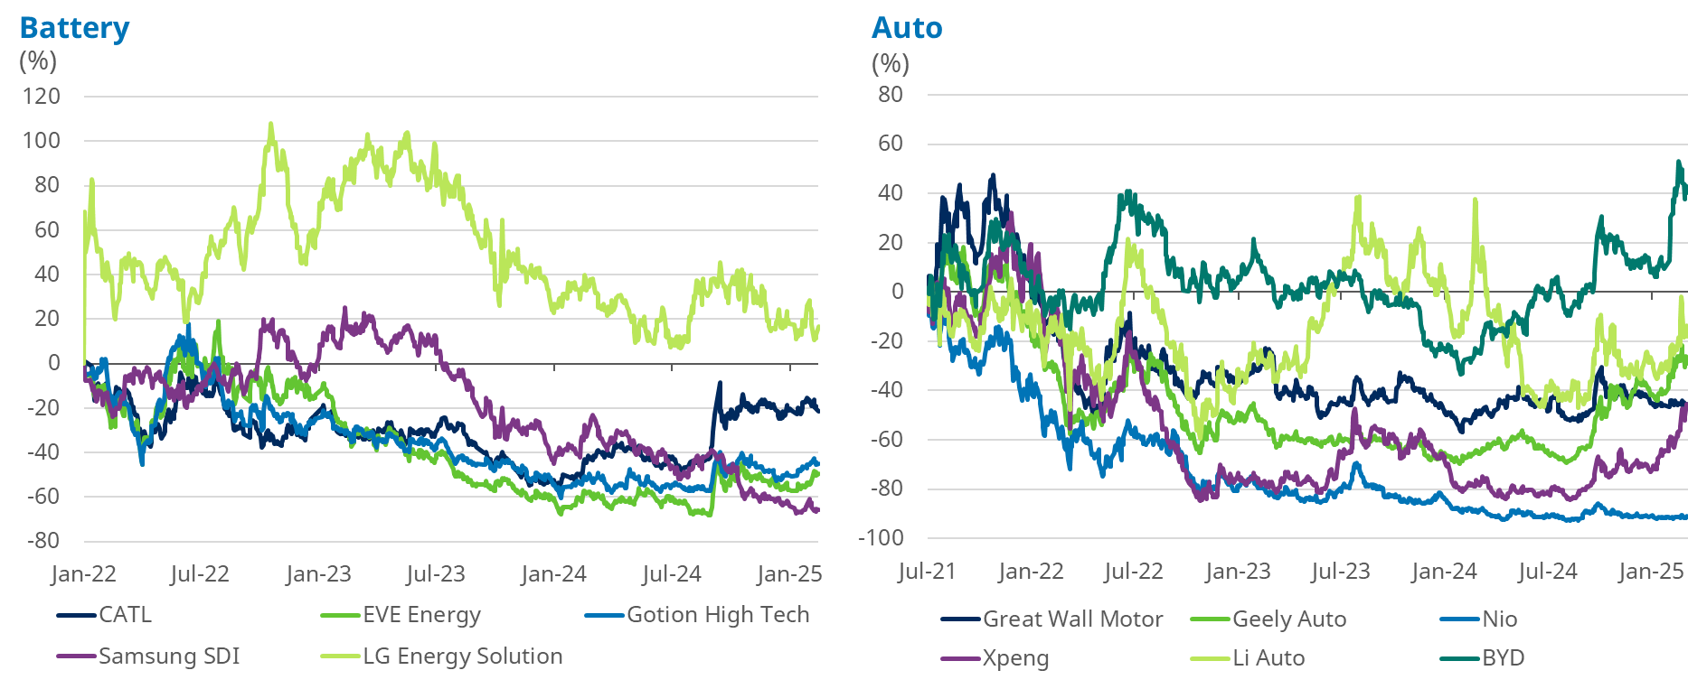

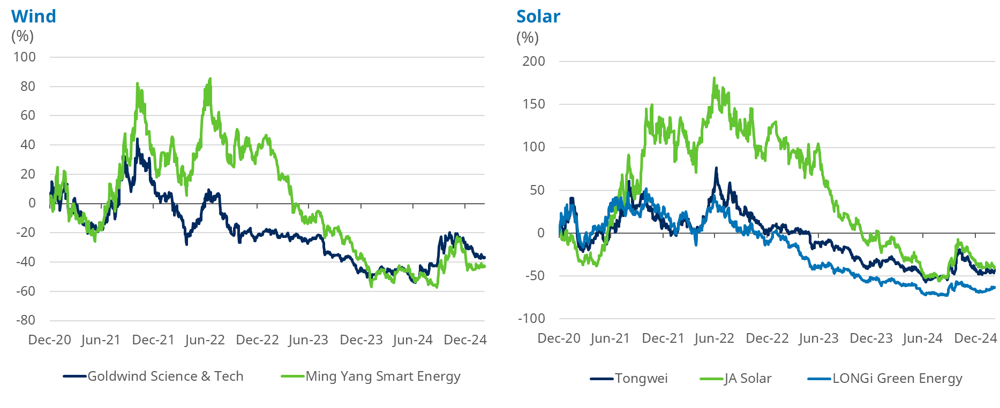

Source: Bloomberg

For the Asian Total Return Fund in a world of high geopolitical uncertainty we instead focus on the secular growth areas where we can see strong MOATS, and rational capital allocation, and good prospective total returns including dividends. Just to recap some of the areas we like are:

* Aging populations and changing technology giving scope for much better diagnosis and treatments of chronic conditions (Australian healthcare holdings)
* Insurance, rising middle classes and better healthcare in Asia (Thai hospitals and Indian healthcare and AIA)
* Financial inclusion as digital platforms and the spread of cheap smartphones allow greater access to financial services (best private sector banks in India, Philippines, Indonesia)
* Long-term global winners due to intellectual property, structural advantages of clustering and supply chains (Taiwan technology, Chinese industrials, Key Asian exporters that can dominate their respective industries)
* Technology services – internet platforms that dominate in sectors that are naturally oligopolistic and where, as it currently stands, A.I. is an opportunity not a threat (Tencent, Meituan, Trip, Grab)
* Well positioned domestic business in “safe” well run and regulated economies that can grow in-line with GDP and offer high dividends (Singapore banks, Australian blue chips).

Robin Parbrook and Lee King Fuei

9th March 2025

**FUND POSITIONING**

Source: Schroders, as at end of February 2025.

For illustrative purposes only and does not constitute any recommendation to invest in the above-mentioned countries.

**TOP 10 HOLDINGS**

|  |  |
| --- | --- |
| Stock | Fund (%) |
| TSMC | 9.7 |
| Tencent | 6.7 |
| Mediatek | 4.2 |
| DBS Group | 3.6 |
| HDFC Bank | 3.1 |
| AIA | 2.9 |
| Aristocrat Leisure | 2.5 |
| Resmed | 2.4 |
| Bank Mandiri | 2.3 |
| Meituan | 2.3 |
| Total | **39.7** |

Source: Schroders, as at end of February 2025.

For illustrative purposes only and does not constitute any recommendation to invest in the above-mentioned countries.